LAB EXPERIMENT RECORD
SET 20: STOCK ANALYSIS
Department | AIDS
Course Code / Course Name | DSA0601 / Data Handling and Visualization
Experiment | Data Visualization using R
Name | B. Pallavi
Register Number | 192424243
Date | 15 October 2026
Day | Thrusday
AIM:
To visualize stock prices, calculate daily percentage changes, and analyze stock performance using R and Excel.
Dataset
Date | Stock A | Stock B | Stock C
2023-01-01 | 100 | 150 | 120
2023-01-02 | 105 | 152 | 118
2023-01-03 | 110 | 148 | 122
Program 1: Line Chart of Stock Prices
R Program:
date <- c("Jan 1", "Jan 2", "Jan 3")
A <- c(100, 105, 110)
B <- c(150, 152, 148)
C <- c(120, 118, 122)
matplot(1:3, cbind(A, B, C),
type="l", lty=1, pch=1,
col=c("red", "blue", "green"),
xaxt="n", xlab="Date",
ylab="Stock Price",
main="Stock Price Analysis")
axis(1, at=1:3, labels=date)
legend("topleft",
legend=c("Stock A","Stock B","Stock C"),
col=c("red","blue","green"), lty=1)
Output: A line chart showing the price changes of three stocks.
Observation: Stock A increases from 100 to 110. Stock B fluctuates, while Stock C decreases and then increases.
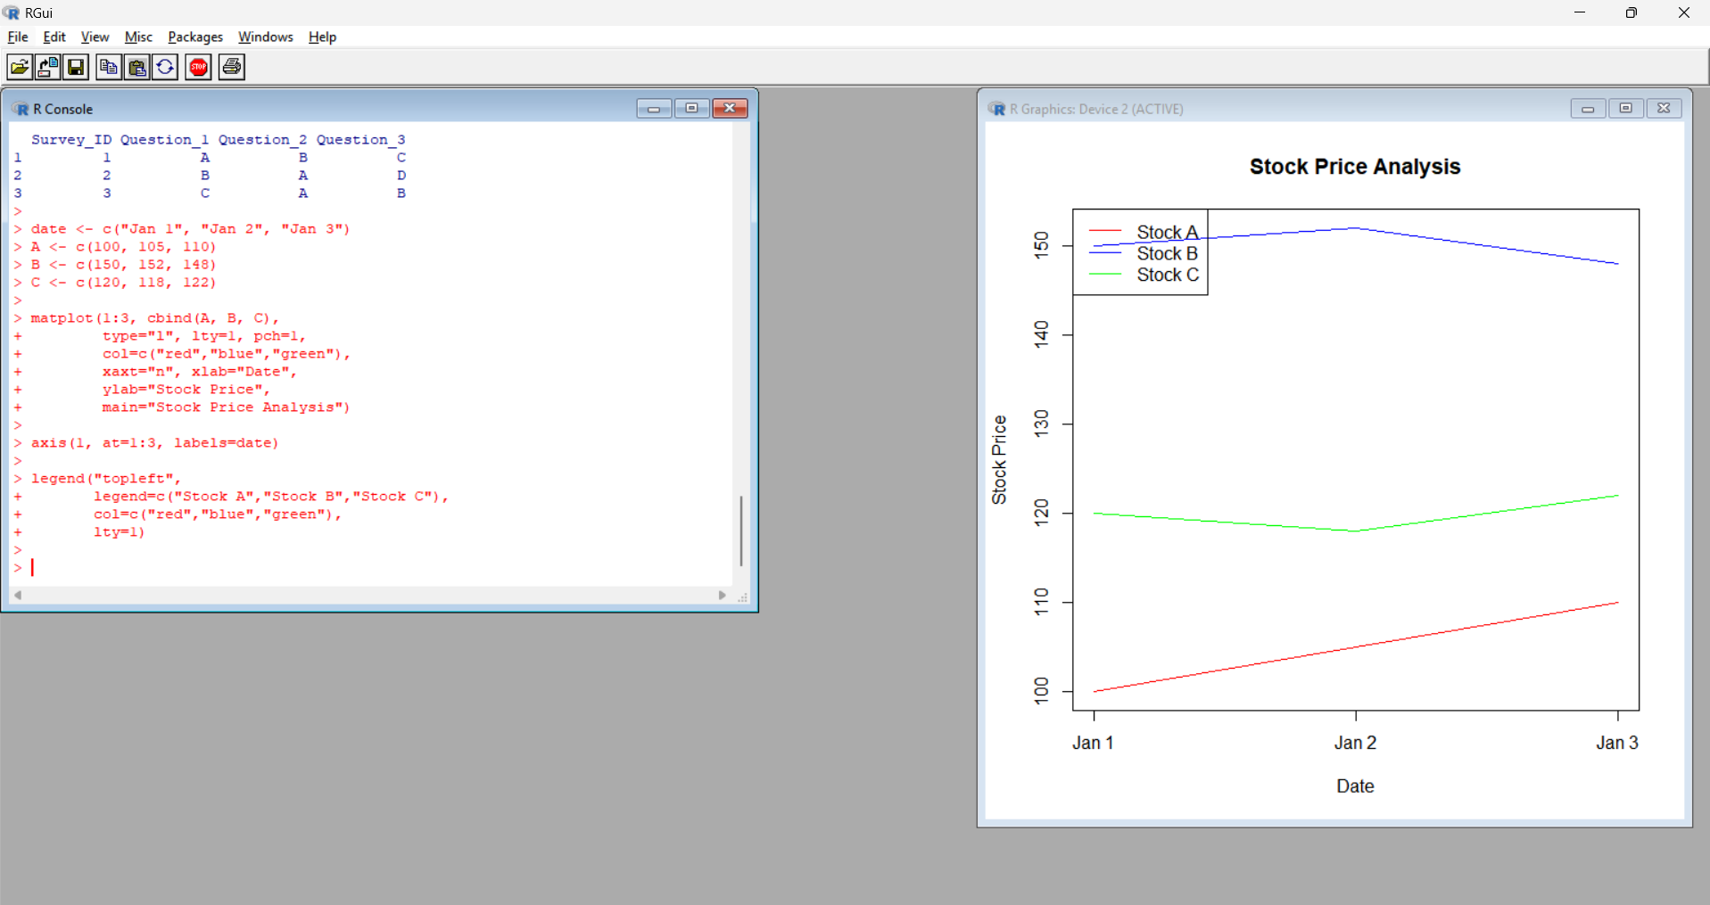
Program 2: Daily Percentage Change of Stock A
R Program:
A <- c(100, 105, 110)

change <- diff(A) / A[-length(A)] * 100
barplot(change,
names.arg=c("Jan 2", "Jan 3"),
col="orange",
main="Daily Percentage Change",
xlab="Date",
ylab="Change (%)")
print(round(change, 2))
Output:
Date | Percentage Change
Jan 2 | 5.00%
Jan 3 | 4.76%
Observation: Stock A shows a positive daily percentage change on both days.
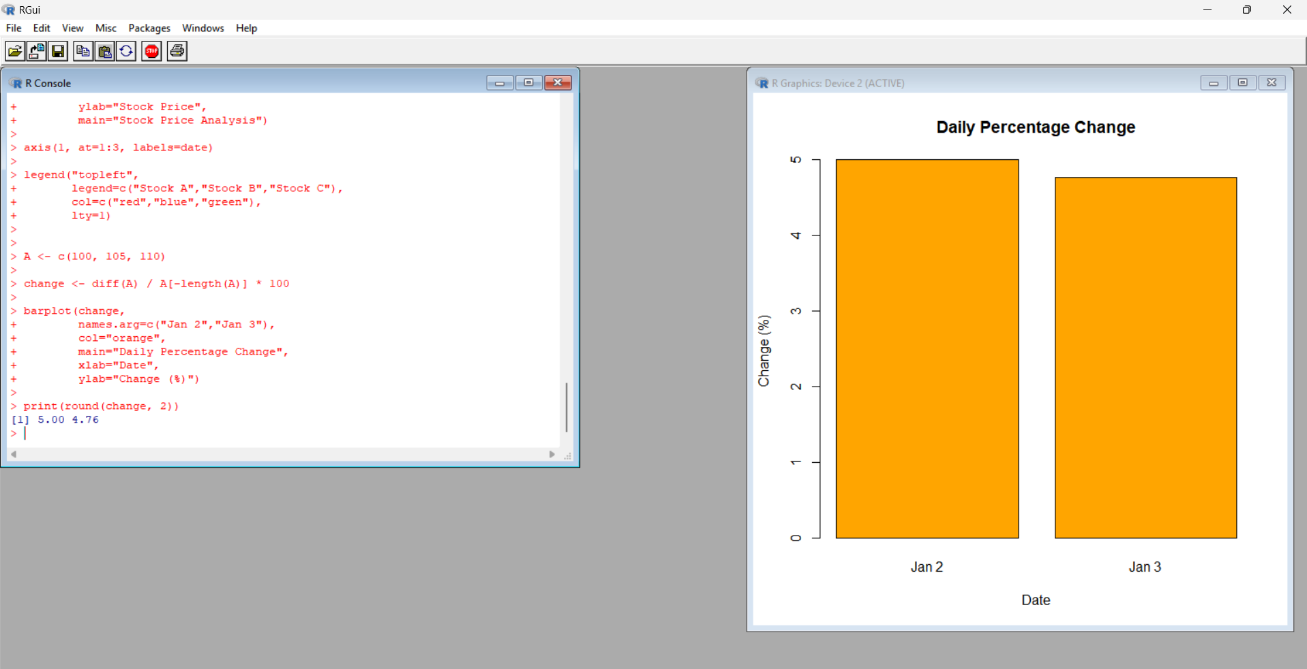
Program 3: Display Stock Data
R Program:
stocks <- data.frame(
Date=c("2023-01-01","2023-01-02","2023-01-03"),
Stock_A=c(100,105,110),
Stock_B=c(150,152,148),
Stock_C=c(120,118,122)
)
print(stocks)
Output: The stock dataset is displayed in the R Console.
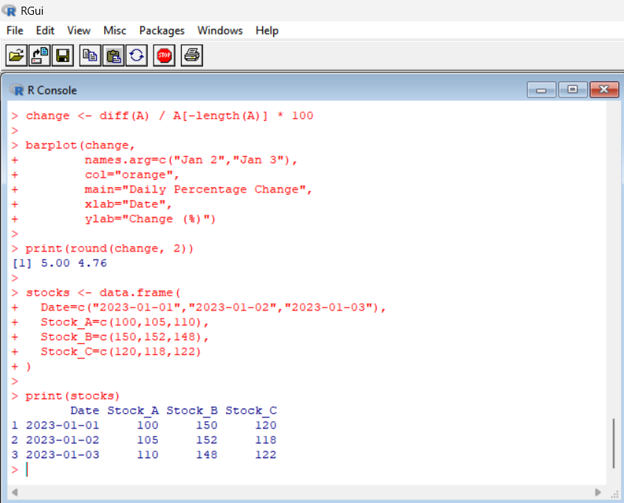
Program 4: Stock Dashboard Using Excel
Procedure:
- Open Microsoft Excel.
- Enter the stock dataset shown above.
- Save the file as Stock_Prices.xlsx.
- Select the Date and three stock price columns.
- Click Insert → Line Chart to create the stock price chart.
- Create a separate column for Stock A percentage change.
- Enter 0% for the first date.
- In the next row, use =(B3-B2)/B2*100 if Stock A prices are in column B.
- Format the percentage column as Percentage.
- Select the dates and percentage changes, then click Insert → Column Chart.
- Arrange both charts neatly on the worksheet.
- Add the heading Stock Analysis Dashboard and save the workbook.
Expected Output: An Excel dashboard containing the stock price line chart and the daily percentage change chart.
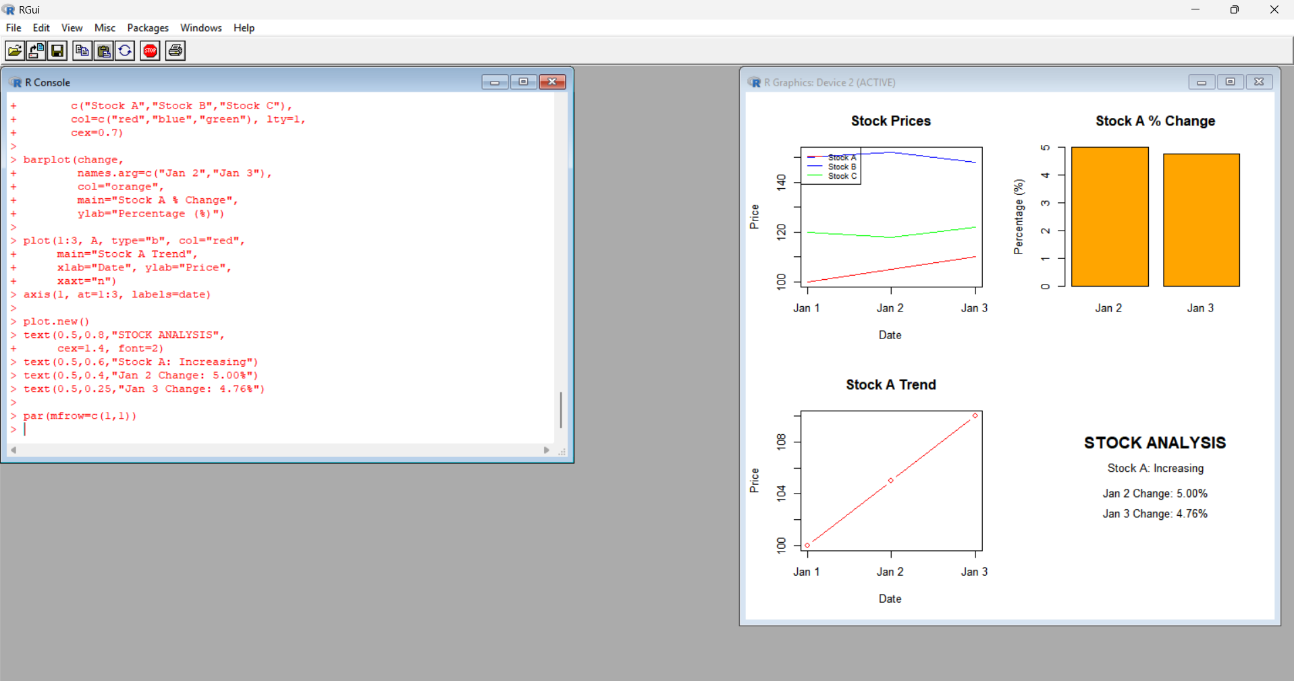
RESULT
Stock prices were visualized using line charts, daily percentage changes were calculated, and an Excel dashboard was prepared to compare stock performance.

